# Template to Copy

**First Name Last Name | Position**

**Phone:** 847-214-0000

**Location:** Building X, Room X000

Elgin Community College

1700 Spartan Drive Elgin, IL 60123

# Instructions to Add in Outlook

1. Start a new email in the Outlook desktop app.
2. Copy and paste the template into the email body.
3. Change the placeholder text to your information.
4. Copy the updated signature.
5. In the ribbon, click the down arrow of the **Signature** icon, then choose **“Signatures…”**  
   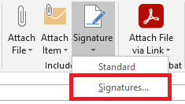
6. Select the **New** button to create a new signature. Give the signature a name.  
   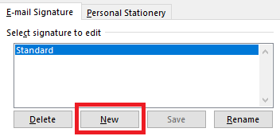
7. Paste into the text box.  
   *Note*: The logo may not appear in the text box but should still appear in the signature.
8. To make this your default signature, select it from the dropdown menu next to the **New messages** option. Click the **OK** button to save.  
   