Below is an exercise split into two parts and multiple sections. It allows you to practice various formatting styles and get comfortable with the structure of the Document Content Type.
Keyboard Shortcuts:  Ctrl + A: Select all.  Ctrl + C: Copy  Ctrl + V: Paste | Terms:  - Content Elements: The fields of the content type that can be edited to create the page's content.  - TinyMCE Editor: The default word-processing application in T4 that allows you to format content.  - TinyMCE Toolbar: The top menu and basic icon shortcuts of the editor.

Resources
- https://docs.terminalfour.com/documentation/managing-content/tinymce/
- https://my.elgin.edu/spaces/marcomm/web-services/knowledge/

Part 1: Setting Up the Basics
Copy and paste the following into the appropriate content elements on the form. You will be pasting into the plain text fields, so no formatting is required.
- Name *: Copy and paste this text.
Employee Equipment Checkout Procedure

- Type *: Select Administrative Procedure/Policy from the list.
- Subject: Enter the name of the procedure.
Employee Equipment Checkout Procedure

- Abstract: Copy and paste this text.
Elgin Community College (ECC) provides college-owned equipment to employees to fulfill work-related responsibilities.

- Procedure ID: Copy and paste the following text.
1.307

- Save changes and Preview the section. You will have a bulleted list with your procedure listed.
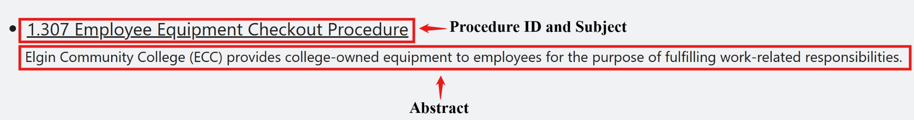

Part 1: Finish Setting Up the Basics
- Close the preview, return to T4, and open the procedure to Edit the content.
- BoT Policy ID: Not always required, but when entered, just enter the appropriate ID.
- Adopted: Choose a date from the calendar widget. Time is not needed and will not display.
- Amended: List the different dates, including the full month name, day, and year (e.g., MMMM DD, YYYY) using a comma (,) or semicolon (;) to separate multiple dates.
March 17, 2006; August 23, 2010; March 20, 2012; July 16, 2016; November 12, 2020; January 13, 2022; June 10, 2022

- Review Cycle: Enter information about the review cycle.
The Vice President will review this procedure for Business and Finance by June 30 of every even-numbered year.

- Last Review Date: This will be your computer's system time by default. To change the value, choose a date from the calendar widget.
- Save changes and preview the section.
- Click on the procedure name to open the document in detail view.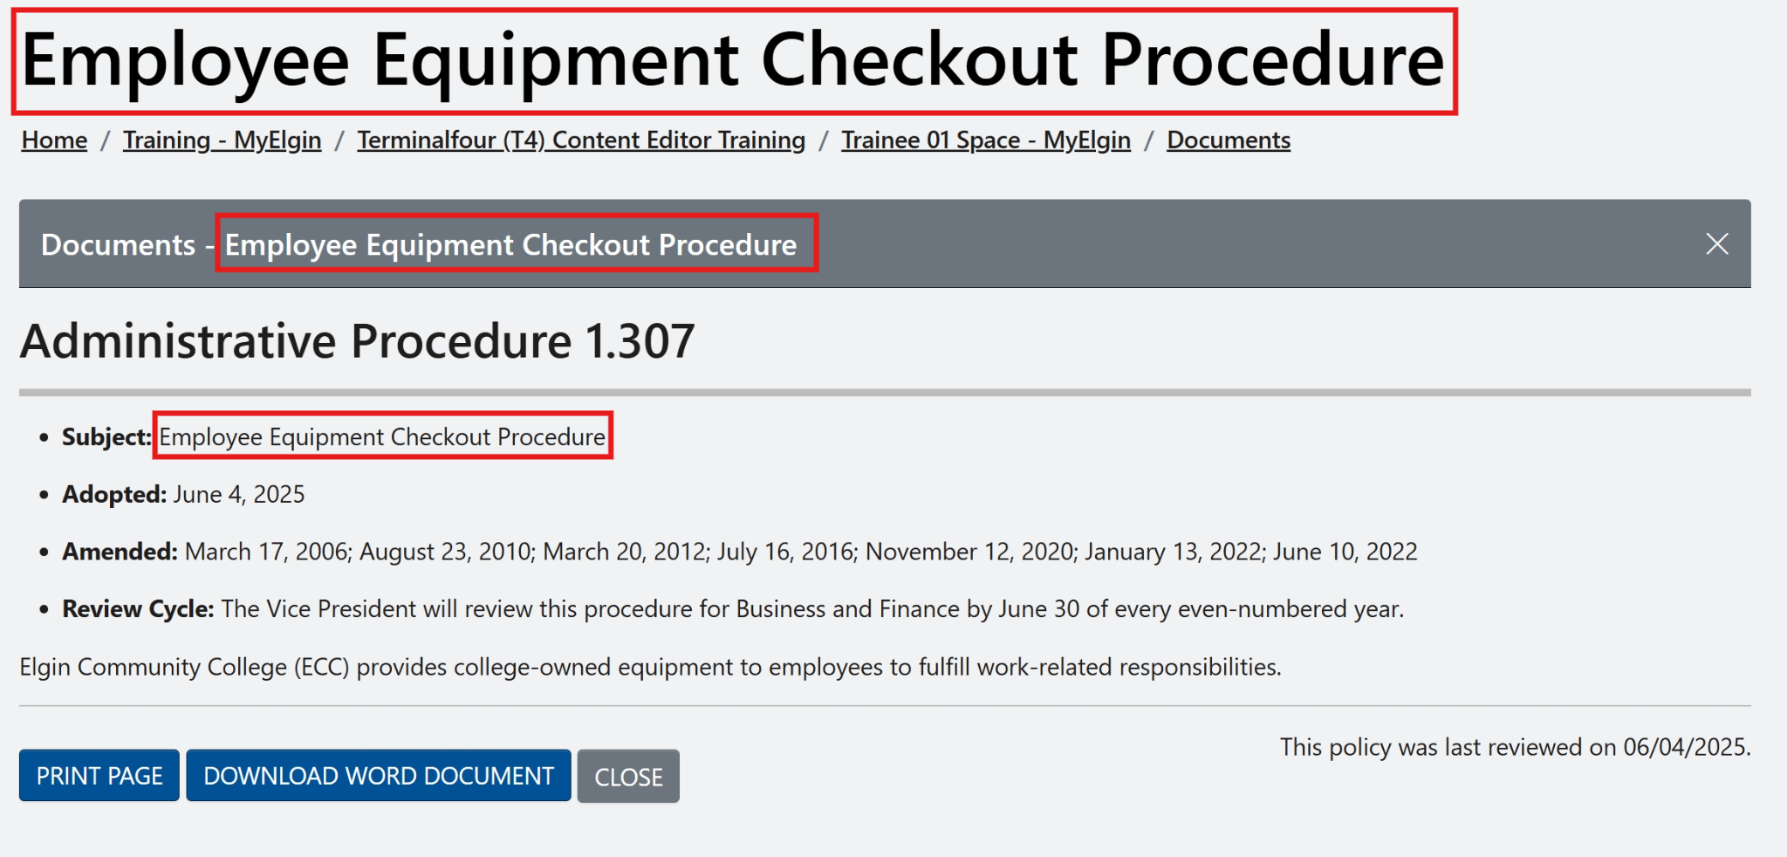
Note: The subject name appears as the page's main header (see red).
- Close the preview and return to T4.

Part 2: Formatting the Document Material
Now it’s time for the Main Body of the procedure. While working on this part of the exercise, you will use the TinyMCE Editor to format the text.
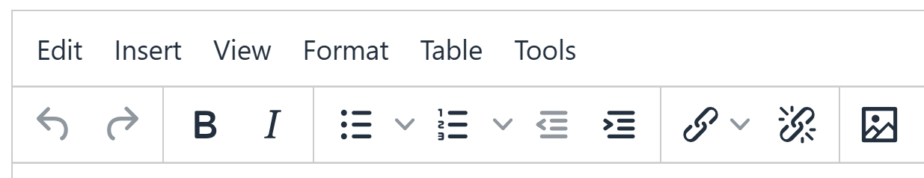

Main Body 1 of 4
- Main Body*: Copy and paste this text.
Related Procedure: 1.112 - Technology Use Policy
Purpose
This procedure ensures proper ECC equipment tracking, usage, and maintenance while holding users accountable for care and return.

  - Clear all formatting.
    - Highlight all the text.
    - From the menu, select Format:
      - Clear formatting

- Apply specific formatting:
  - Highlight Related Procedure
    - Click on B to bold the text.

  - Highlight the text 1.112 - Technology Use Policy.
    - Click on the Chain icon.
      - Select the Link to External Site:
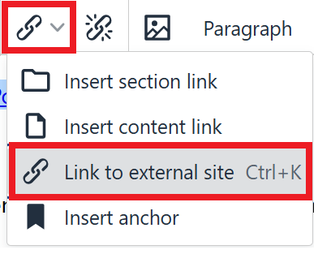
        - Add URL: https://t4dev-my.elgin.edu/procedures/section-1-instruction/student-grades.php
        - Add Title:
Review the 1.112 - Technology Use Policy to learn more.

  - Highlight the text Purpose.
    - From the menu, select Format:
      - Blocks
        - Select Heading 3 (H3)
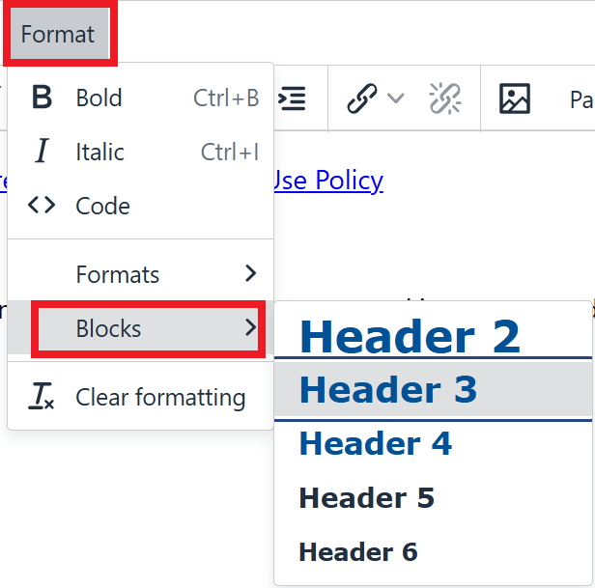
- Save changes and Preview the section.
- Click on the procedure name to open the document in detail view.
- Close the preview and return to T4.

Main Body 2 of 4
- Main Body*: Copy and paste this text after the existing formatted text you completed in the last step.
Eligible Equipment
Employees may check out the following equipment:
Laptops
Projectors
Mobile hotspots
Webcams or headsets
iPads or tablets

  - Clear all formatting.
    - Highlight all the text.
    - From the menu, select Format:
      - Clear formatting
- Apply specific formatting:
  - Highlight the text Eligible Equipment.
    - From the menu, select Format:
      - Blocks
        - Select Heading 3 (H3)
- Highlight the text: Laptops, Projectors, Mobile hotspots, Webcams, headsets, iPads, or tablets.
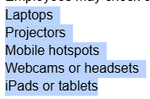
  - Click on the Bullet List icon.
    - This will format the list as an unordered list.
- Save changes and preview the section.
- Click on the procedure name to open the document in detail view.
- Close the preview and return to T4.

Main Body 3 of 4
- Main Body*: Copy and paste this text after the existing formatted text you completed in the last step.
Checkout Process
To request equipment, employees must follow this process:
Complete the ECC Equipment Checkout Request Form, located on the ECC intranet.
Obtain approval from your immediate supervisor.
Submit the form to the IT Help Desk three (3) business days before the equipment is needed.
Pick up the equipment from the IT Help Desk during regular business hours.

  - Clear all formatting.
    - Highlight all the text.
    - From the menu, select Format:
      - Clear formatting
- Apply specific formatting:
  - Highlight the text Checkout Process.
    - From the menu, select Format:
      - Blocks
        - Select Heading 3 (H3)
- Highlight the text: Complete the ECC Equipment Checkout Request..., and all that comes after.
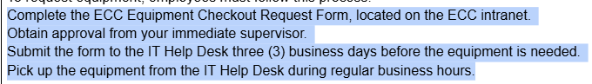
- Click on the Numbered List icon.
  - This will format the list as numbered to indicate steps in a specific order.

Main Body 4 of 4
In this part, we’ll cover adding hyperlinks to your content.
- Main Body*: Copy and paste this text after the existing formatted text you completed in the last step.
Support
For assistance or technical support, please call the IT Help Desk at 224-523-2222, email helpdesk@elgin.edu, or visit the ECC Technology Services page.

  - Clear all formatting.
    - Highlight all the text.
    - From the menu, select Format:
      - Clear formatting
- Apply a heading format:
  - Highlight the text Support.
    - From the menu, select Format:
      - Blocks
        - Select Heading 3 (H3)
- Add a phone number hyperlink:
  - Highlight the phone number text 224-523-2222.
    - From the TinyMCE Toolbar, click on the Chain icon.
    - Select the Link to External Site:
      - Add URL:
tel:224-523-2222

      - Add Title:
Call 224-523-2222

- Add an email hyperlink:
  - Highlight the email text helpdesk@elgin.edu.
    - From the TinyMCE Toolbar, click on the Chain icon.
    - Select the Link to External Site:
      - Add URL:
mailto:helpdesk@elgin.edu

      - Add Title:
Email helpdesk@elgin.edu

- Add a hyperlink to a new web page:
  - Highlight the text Technology Service.
    - From the TinyMCE Toolbar, click on the Chain icon.
    - Select the Link to External Site:
      - Add URL:
https://elgin.edu/student-services/technical-help/

      - Add Title:
Visit elgin.edu/student-services/technical-help for more information.
      - Open link in...
        - Choose: New Window
- Save changes and preview the section.
- Click on the procedure name to open the document in detail view.
- Close the preview and return to T4.

